Misc gilvary history

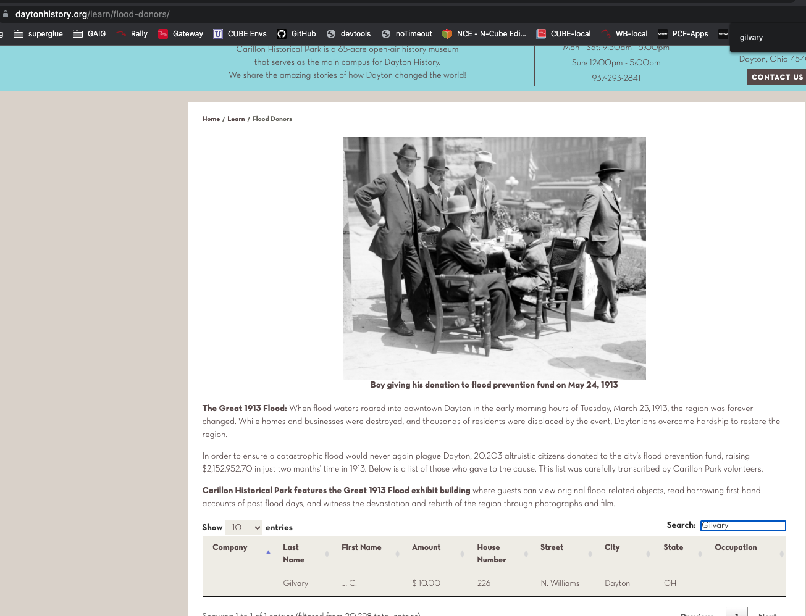

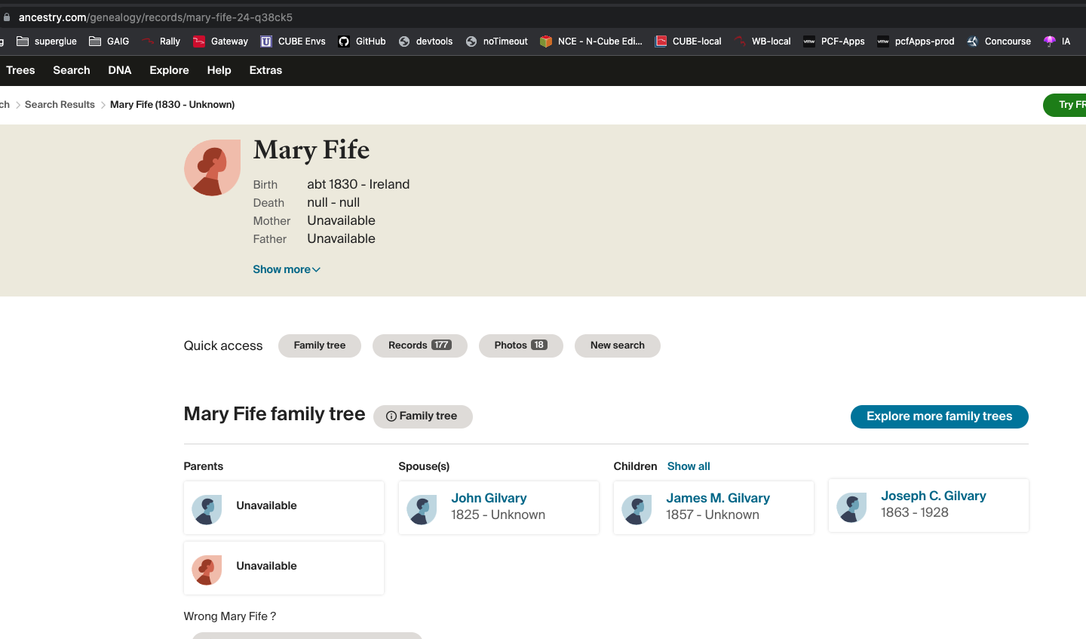

Wednesday 29 May

BOSHLER, Charles..62 yrs..79 Sackett St

BLOHM, John W. H...26 yrs..361 Halsey St

CURLEY, Agnes..4 yrs..134 N. Portland Ave

COWPERTHWAIT, Hazel A...2 yrs..563 10th St

CANFIELD, Rose..1 mo..607 Vanderbilt St

COLELLA, Antonia..5 mos..54 Park Ave

DYHEZYNSKI, Jennie..4 yrs..300 Henry St

DESOLA, Marion..2 days..232 Prospect St

DAVIS, George T...48 yrs..151 Nassau St

DAY, Elizabeth..65 yrs..30 Montrose Ave

FRAZER, Mary A...8 yrs..311 Jefferson Ave

FOGARTY, Elizabeth..8 mos..136 23rd St

FAASZ, Elizabeth..51 yrs..26 Central Ave

FOX, Kattie..42 yrs..170 Hall St

GARRISON, John..17 yrs..444 17th St

GILVARY, Redmond J...26 yrs..St. Mary's Hospital

